NICER
National Institute for
Christian Education Research

The Beginning Teacher in the Science/Religion Encounter:
Building Confidence for an Integrated Vision of Knowledge.

Briefing Document for Advisory Group (virtual) Meeting

Project Lead: Professor Robert A. Bowie Advisory Group Meeting
9th March 2021

Programme

Please note: The meeting will be recorded for the benefit of Team members unable to attend this meeting.

10.00 | Welcome and Introductions | Bob Bowie
10.10 | Update to Beginning Teachers in the Classroom Project | Bob Bowie
10.25 | Sub-Project 2 Focus  - The conceptual map we are using for the survey design.  - A focus on an exemplar question from the survey with discussion on the categories used to understand possible relationship between science and religion.  - What questions do we want to ask of the data we hope to get? | Sabina Hulbert  Mary Woolley  Mary Woolley and  Sabina Hulbert
10.55 | Break
11.05 | How are we to engage with our target audiences?  - In terms of disseminating the survey to maximise responses.  - In terms of effecting change for teacher education and development (events, resources, measuring impact of change). | Bob Bowie
12.00 | Agree the next meeting and close

March 2021 Report

Despite the temporary easing of restrictions as a result of the pandemic following the national lockdown which began in March 2020, since the Advisory Group first met on 22nd June 2020, Kent, which is where the Project is based, has been experiencing some of the tightest restrictions as a result of COVID-19 with the county moving from Tier 3 to Tier 4 in December 2020. This was followed by a further national lockdown which came into effect in January 2021. Notwithstanding the additional challenges this has posed, the Team has developed solutions at short notice to a number of unanticipated problems it presented.

The Project remains largely on track with the timeline with Team members having continued to be flexible in their approach to the Project and making adaptations to the Project and working patterns as required and a number of reports have been submitted to Templeton World Charity Foundation addressing key areas such as the Project schedule, significant accomplishments and any other additional reporting requirements.

SP1 - SP1 remains largely on track with journal article writing progressing as expected. Although it has not been possible during the reporting period for the researchers to make further visits to schools in order to obtain additional data or for report writing to progress as originally planned, analysis of the data collected to date is almost complete and adjustments have been made to the Project timeline such that these activities can be expected to be completed within the duration of the grant. Secondary school data gathering will continue when COVID-19 restrictions allow and, if appropriate, reports that have been written without the secondary data can be amended when this additional data is available. Two articles are in development (the first nearly complete) recording key aspects of the findings and outputs have been shared at internal and external events engaging Religious Education and Church school education audiences.

SP2 - A second stage of focus groups took place during Autumn 2020 concluding in December 2020 ahead of schedule. Providing a range of rich data, this latest stage of focus groups included a Year 3 Secondary RE with QTS Undergraduates cohort from a newly-recruited participating university. Transcription, coding and analysis of the data has taken place and the data has been used to inform and shape the online survey which is on track for completion as planned. To support that design the literature search that was carried out at the time of the Project proposals has been extended to incorporate new insights into the survey design but also because a seeming lack of or inconsistency of knowledge and indeed epistemic knowledge seems to have been a feature of the focus group responses. A first draft has been prepared for pre-testing with some student teachers with specific questions to be shared and discussed with the Advisory Group. It is expected that data can be collected between mid-March and the end of May unless it becomes necessary to reschedule due to COVID-19.

In addition to the work carried out on the online survey, a draft list of resource ideas on Science/Religion Encounters for Beginning Teachers has been compiled. This will be shared and discussed with representatives from participating universities at a number of meetings that have been arranged. Best practice for dissemination of the survey to the maximum number of relevant participants will also be discussed at these meetings.
Work Done Since the Advisory Group Met on 22nd June 2020

- Professor Bob Bowie has presented a paper on the Project to the RExChange conference event on 3rd October 2020.

- A local virtual seminar at Canterbury Christ Church University was held on 7th October 2020 with papers presented by Professor Lynn Revell and Dr John-Paul Riordan on SP1 for local RE teachers and university students and tutors (20).

- An initial meeting of the teacher educators’ network with tutors from all of the participating universities took place on 8th October 2020.

- Dr Mary Woolley presented a paper, Crossovers and collaborations: beginning teachers’ perceptions of opportunities for science/ religion encounters in the classroom and Professor Revell presented a paper, Curating superficiality: a comparison of two lessons on the Creation Story on the Project to the Church of England Inaugural National Research Conference ‘Vision into Practice’ on 17th November 2020 – ZOOM – 70 School leaders/ diocesan leaders.
(https://cofefoundation.contentfiles.net/media/assets/file/CEFEL_Research_Conference_-_Vision_into_Practice_-_17_November_2020_cV3fhsP.pdf).

- On 29th January 2021 Professor Bob Bowie gave a verbal general update on the Project to the Education sub-committee of The Cathedrals Group of Universities.

- Professor Bob Bowie highlighted the Project on 29th January 2021 to a meeting of 30 South East England HMI (school inspectors).

- A number of meetings with representatives from participating universities have been arranged with the first one having taken place on 24th February 2021.

- A number of papers have been submitted for important conferences for Teacher Education networks including the Teacher Education Advancement Network (TEAN) conference which is due to take place online on 6th and 7th May 2021 (https://tean.ac.uk/). The TEAN conference brings together a large network of teacher education tutors and constitutes the biggest gathering of this category of professionals in England.

- Submissions have been made for the Association of University Lecturers in Religion and Education (AULRE) conference in May 2021 (aulre.org) and to the British Educational Research Association (BERA) conference in September 2021 (https://www.bera.ac.uk/conference/bera-conference-2021) where initial findings can be disseminated and the network impact interest developed.

- Professor Neil Messer has been invited and agreed to join the Group. With expertise in theology, science and ethics, it is anticipated that Professor Messer will have much to offer in taking the Project forward.

- The nicer.org.uk website for the Project continues to be developed and now includes a ‘Meet The Team’ page - https://nicer.org.uk/about-us/people.
Major Project Activities

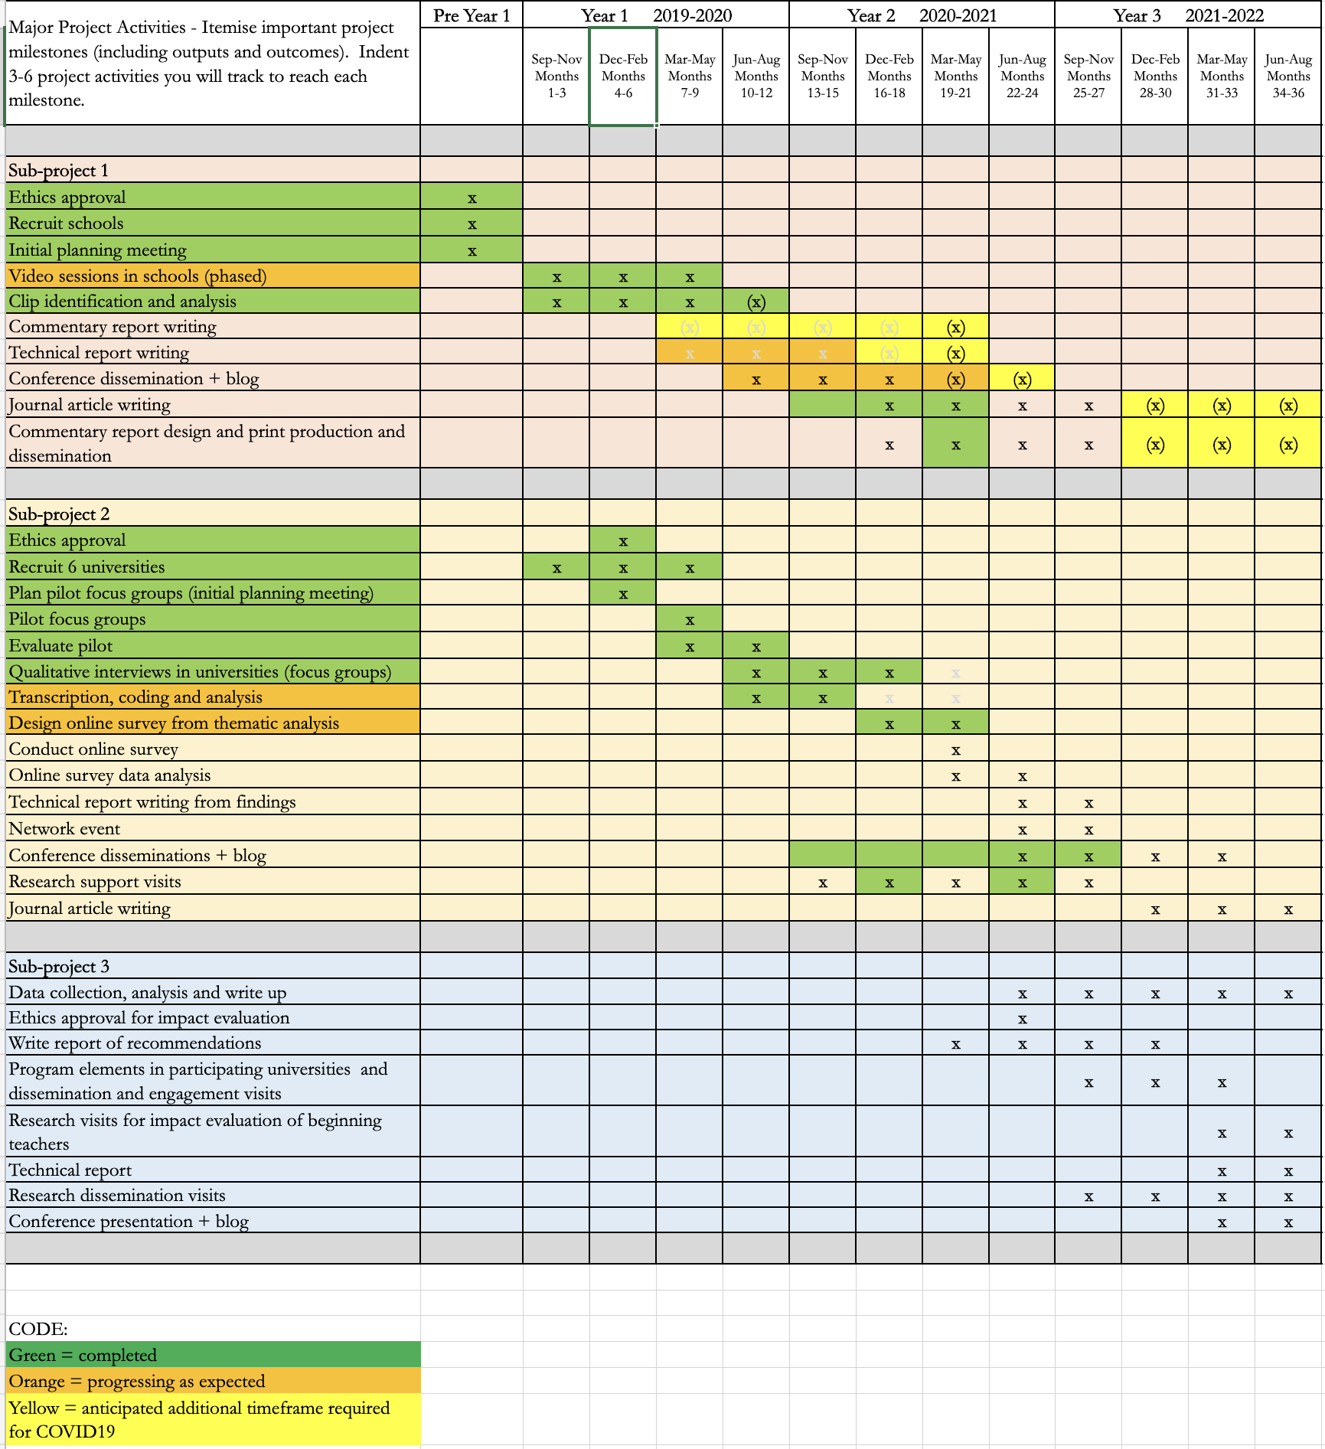
The Team

Professor Bob Bowie
Professor of Religion and Worldviews Education and Director of NICER

Ms Gill Harrison
Project Administrator

Dr Sabina Hulbert
Senior Researcher in Quantitative Research Methods and Statistics

Professor Lynn Revell
Director of Research and Reader in Religion and Education

Dr John-Paul Riordan
Senior Lecturer and Researcher

Dr Deborah Scott
Researcher

Ms Caroline Thomas
Senior Lecturer and Researcher

Dr Mary Woolley
Senior Lecturer and Researcher

Additional Note

There is considerable scope to recruit additional survey participants and pave the grounds for impact audiences through the following groups and networks that the NICER can access:

- The Association of University Lecturers in Religion and Education (BB is an executive officer) accesses most teacher education RE specialists in the UK and therefore potentially their students (Beginning Teachers in training).

- RE professional networks including National Association of Teachers of RE (NATRE) and Association of Teachers of Catholic Religious Education (ATCRE) – professional associations of RE teachers (Beginning Teachers in NQT years 1 and 2).

- Facebook groups for RE teachers, e.g. REspect (formally SaveRE) (Beginning Teachers in NQT years 1 and 2).

- DDE Networks (Church of England diocesan groupings of schools (Beginning Teachers in NQT years 1 and 2).

Abstracts Submitted for Education Conferences in 2021

Worldview and how knowledge works: teacher education learnings from beginning teachers and science religion encounters in the classroom

Bob Bowie, Mary Woolley, Caroline Thomas, Lynn Revell, John-Paul Riordan, Sabina Hulbert

The paper presents some early evidence from a major mixed methods research project, using focus groups, lesson observations (later a large-scale survey) focussed on beginning teachers and ‘science religion encounters in the classroom’. In the first qualitative phase we explored participants’ experiences of SRE in focus groups interviews to gain a rich understanding of what characterised their experiences, attitudes and behaviours in relation to SRE.

Subsequent analysis shows an example of how teacher education is a site of the interplay between worldview (variously understood as cognitive linguistic, personal and community/cultural influences, factors and systems of making meaning), curriculum and disciplinary knowledge. Initial teacher education is therefore in principle a stage in the shaping of teachers to be reflexive around these elements as they will influence curriculum and lesson organization and subject aims.

Discussion relating to worldview links the term used to political, ethical or religious ways of life and ways of framing the world. Public debate during the last UK General Election referred to Jeremy Corbyn’s worldview and the UK The High Court recognized ethical veganism as a philosophical belief or worldview meriting human rights recognition like other religions or belief systems. New research about worldview, has investigated cognitive dispositions and the ability to complete complex tasks (Zmigrod, Eisenberg, Bissett, Robbins 2021).

The religious education subject area in England and other countries are at different stages of integration a change towards worldview education for better account of the plurality and diversity of religious and non-religious belief systems (der Kooij, Ruyter & Miedema, 2017). The concept has its advocates (Cooling 2020) and critics (Barnes 2015).

How worldview concepts frame the curriculum are sometimes controversial as illustrated in the debate in the House the House of Commons around teaching White Privilege as a contested or uncontested fact (Hansard 2020). At present conceptualizations of worldview vary. Worldview has implications for conscientious professional conduct. Government regulates undue influence from teachers through professional values regulation as the promotion of partisan political views in schools is prohibited in sections 406 and 407 of the 1996 Education Act (https://www.legislation.gov.uk/ukpga/1996/56/part/V/chapter/IV/crossheading/politics). Advocates of social justice seek decoloniality in the curriculum and character educationalists promote a virtue literacy in the formulations of curriculum and pedagogy. This is a site of contention.

This paper outlines evidence from the focus groups that worldview may be a useful tool to understand how student teachers make sense of the way knowledge works in their subject and in school classrooms.

It argues for more specific opportunities for conscientization of teachers in worldview, more attention to be given to worldview in pedagogy to help teachers better understand the factors that influence their personal worldview, the ways they discern, adopt and perhaps implicitly or explicitly advance certain frames in curriculum organisation, certain kinds of reasoning, and possible links between cognitive aspects of learning and worldview.

Experiences of beginning teachers as to how knowledge works in ‘science/religion encounters’ in the classroom

Mary Woolley, Caroline Thomas, Sabina Hulbert, Bob Bowie, John-Paul Riordan

This research emanates from a large-scale, Templeton World-funded project exploring science/religion encounters (SRE) in primary and secondary classrooms. This paper draws from a particular part of the project which sought to discover the experiences, competence and confidence of beginning teachers in this complex and potentially contentious area.

The relationship between science and religion has been the subject of substantial research (McGrath, 2020; Spencer, 2019). There have been several attempts to create a typology of possible relationships between the two disciplines (Barbour, 2000; Messer, 2020). Research has also focused on the pupils’ attitudes to the relationship between science and religion (Billingsley, Abedin and Nassaji, 2020; Astley and Francis, 2010). There has been some focus on teachers’ approaches to such encounters (Subedi, 2006; Mansour, 2015) but little previous research on beginning teachers’ experiences of SRE in England. It is crucial to engage with the prior epistemological assumptions and presumptions of beginning teachers in order to support teachers in handling potentially sensitive SRE.

The study adopted a mixed method approach. In the first qualitative phase we explored participants’ experiences of SRE in focus groups interviews to gain a rich understanding of what characterised their experiences, attitudes and behaviours in relation to SRE. The second, quantitative, phase used an online survey to test the relationship between the various constructs and identify a causal path for the significant predictors of confidence in the teaching of SRE. The research design involved recruitment of six university providers of initial teacher education to enable semi-structured focus groups with over 60 pre-service teachers across two academic years. These included primary student teachers, secondary student teachers of RE and science, and student teachers from undergraduate, postgraduate and Schools Direct programmes. Data from the focus groups was transcribed and analysed according to emergent themes. Examples from the focus group data, along with broader literature, were used to design an online survey instrument. This instrument was designed to explore 5 distinct, but related areas: experience of ‘science/religion encounters’, perception of the relationship between science and religion, competence in planning for and responding to such encounters (including substantive knowledge and articulation of purpose), confidence in teaching for such encounters and barriers/ support mechanisms for such encounters. Various networks were employed to disseminate the online survey among pre-service teachers and teachers in the first two years post qualification to enable a large number of respondents from across the country. A robust ethical framework was agreed by the university ethics committee to ensure the informed consent and anonymity of participants, to prioritise participants’ welfare and to ensure appropriate safeguarding of data. The framework was based on BERA (2018) guideline and was approved by the university’s ethics committee.

Initial findings from the focus provide insights into student teachers’ understanding of the purposes of science and religious education and where encounters between the two subjects occur, either from pupil questioning or teacher planning. For the primary student teachers, limited opportunities to observe and teach science and religious education on school placement influenced their views on the subjects’ place within the primary curriculum and therefore their confidence to engage with science and religion encounters. Several focus groups discussed fear of parental reaction if potentially sensitive topics were touched upon. For the secondary school student teachers of science and RE it was found that student teachers’ understanding of the purpose of the ‘other’ subject often derived only from their own school experience which led to a limited understanding of the full nature and purpose of the other subject, in particular science teachers’ conceptions of Religious Education.

This paper will share the initial findings from the online survey of 1000 beginning teachers across England. It will also discuss student teachers’ reactions to university sessions which brought together students from the two different disciplines. It will question how beginning teachers might best be prepared to articulate the purpose of both subjects on the curriculum in order to best support the progress in understanding of their pupils. The findings of this research are significant for science, RE and primary teachers and teacher educators seeking to prepare beginning teachers to teach potentially sensitive issues at the interface between one discipline and another. There are also lessons here for those interested in the place of knowledge in both curriculum leadership and teacher development.
“It’s not something I would have considered”: Primary Trainee Teachers’ Perspectives on Science Religion Encounters in the Primary Classroom

Caroline Thomas

This paper explores primary trainee (pre-service) teachers’ perspectives on their confidence and competence to engage with science religion encounters (SRE) in the classroom. These encounters include planned lessons, experiences observed on school placements and those arising naturally from pupils’ questions. The research formed part of a large-scale Templeton-funded research project investigating primary and secondary beginning teachers’ experiences of science religion encounters across six universities in England. Beginning teachers include both pre-service teachers and qualified teachers in the early phase of their careers. In total, 17 focus groups were conducted (February to December 2020). Previous research into pre-service teachers’ experience is sparse. Research to date focuses on primary school students’ perspectives on questions that bridge science and religion (Billingsley, Abedin, and Nassaji, M., 2020). The theoretical framework underpinning the analysis was based on typologies characterising the possible relationships between the two disciplines (Barbour, 2000; Messer, 2020).

The paper draws on the findings of five focus groups undertaken face-to-face or electronically. The focus groups explored trainees’ experiences of planning for and managing science religion encounters, the issues and challenges they faced, and sources of support. The sample included undergraduate and postgraduate trainees, those at the beginning and near completion of their programmes. A robust ethical framework underpinned the focus group protocol to prioritise participants’ welfare. The framework was based on BERA (2018) guidelines and approved by the University’s ethics committee.

The findings provided insights into trainees’ understanding of the purposes of science and religious education. They indicated trainees experienced limited opportunities to observe and teach science and religious education in school. These limitations influenced their views on these subjects’ place within the primary curriculum and their confidence to engage with science religion encounters. In one University, trainee engagement with ‘epistemic insight’ stimulated positive conversations about the relationship between science and religion in the primary classroom. Epistemic insight seeks to enable children to develop the attitudes and understanding associated with thinking and working like a scholar (Billingsley and Hardman, 2017). The findings informed the construction of a questionnaire to survey 1000 beginning teachers’ experiences of SRE.

The paper seeks to stimulate discussion amongst conference delegates about preparing trainees to enable pupils’ exploration of science religion encounters. Such preparation should equip them to address sensitively issues and questions that cross the disciplinary boundaries. Part of the paper includes sharing some of the initiatives introduced at Canterbury Christ Church University in this respect.

Video-based grounded theory study of primary classroom strategy: pedagogical problem-solving when science and RE topics interact

John-Paul Riordan, Lynn Revell, Bob Bowie, Mary Woolley, Sabina Hulbert, Caroline Thomas

Background: In school, when science issues emerge during RE lessons, and when religion is discussed in science lessons, teachers and pupils can face challenging pedagogical problems. For example, contemporary science and the key texts of the world religions (e.g., the Bible, Koran, Vedas, Sutras, etc...) give differing accounts of the origins of the universe which pupils, and their teachers, might find confusing (Hopfe and Woodward, 2009). The focus of this paper is on understanding and explaining pedagogical problem solving, using science/religion encounters during lessons as exemplars. As ‘pedagogy’ and ‘problem’ are contested terms they will be defined carefully (Watkins and Mortimore, 1999; Leach & Moon, 2008; Alexander, 2008, Black and Wiliam, 2018; Jonassen, 2000; Robertson, 2017). Research designs exploring pedagogical problem-solving should investigate teachers’ thinking processes and include pupil interpretations (Limón 2001; Riordan, 2020).

Purpose: Teachers and pupils in classrooms solve, and fail to solve, many conceptual and pedagogical problems during lessons, but it is not obvious what a pedagogical problem is, what types of pedagogical problem there are, nor what people do to address such problems. This research used video-based pedagogy analysis in a primary school of one science and one RE lesson where science and religion topics interact to understand and explain some aspects of pedagogical problem-solving. Understanding pedagogical problem-solving is important because part of education is to teach learners to solve conceptual and pedagogical problems themselves, and part of Initial Teacher Education is to teach teachers how to analyse and solve pedagogical problems. Indeed, “the central point of education is to teach people to think, to use their rational powers, to become better problem solvers” (Gagné, 1980, p. 85). This paper integrates the Pedagogy Analysis Framework (Riordan, 2020) with an analysis of pedagogical problem-solving, illustrating the resultant extended Pedagogy Analysis Framework and Pedagogical Problem Typology using data from a video-based study of one science and one RE lesson. The research design builds on previous work (Riordan, 2020; Riordan, Hardman and Cumbers, in review) by exploring primary school and RE pedagogy.

Research questions: 1. How are pedagogical problems addressed by participants during one primary science lesson about the Big Bang and one primary RE lesson about ‘creation’? 2. What types of pedagogical problem are there?

Sample: One class of thirty 7-year-old pupils, and another class of 10-year-olds, each with their class teacher and teaching assistants, participated. The teachers were recruited by contacting nearby primary schools directly, so a convenience sample was used. Pupil Group Verbal Protocol interviews were with six volunteers from each class. Videos were analysed by the class teacher, the pupils who took part in the Pupil Group Verbal Protocol interviews and two researchers.

Design and method: Four research methods were used (lesson video analysis, teacher verbal protocols, pupil group verbal protocols and individual teacher interviews). Combining verbal protocols with interviews was originally proposed by Taylor and Dionne (2000), and such an approach can give a rich data set (Leighton, 2017). Data were video recorded (and managed using NVivo). More than six hours of video data were analysed using Grounded Theory Methods by two educational researchers, the class teacher and two groups of pupils (three girls and three boys). We took a pragmatic approach to coding as recommended by Bryant and Charmaz (2010). The interpretivist theoretical perspective (symbolic interactionism) was underpinned by a social constructionist epistemology (hence the methodology is Straussian Grounded Theory). Appropriate criteria for evaluating the emergent grounded theory were used (Lincoln and Guba, 1985). Data were recorded in 2019.

Results: This paper presents and exemplifies an extended Pedagogy Analysis Framework and the following Pedagogical Problem Typology:

1. Prior knowledge problems
2. Context problems
3. Knowledge about knowledge problems
4. Volition problems 2/26/2021 BERA Annual Conference 2021
https://www5.shocklogic.com/scripts/jmevent/profile.php?action=viewSection&section=loadForm&tab=abstracts&url=P2FjdGlvbj1hYnN0cmFjdFN1Ym… 2/3
5. Intended means, strategy and/or ends problems
6. Enacted means, strategy and/or ends problems
7. Solver problems
8. Solitary or social problems
9. Time and/or space problems
10. Grand strategy problems

Conclusion: The extended Pedagogy Analysis Framework and Pedagogical Problem Typology can help during pedagogy analysis to identify, understand and explain common and less common types of pedagogical problem. These emergent theories can clarify some of the types of pedagogical problem that teachers and learners encounter daily, and to understand and explain (with the help of some educators and pupils) how participants sought to solve those problems. Hence the ambition here is to make progress in constructing an understanding of pedagogical problem solving, not to provide some comprehensive solution. This research design works with young children. “It is a familiar and significant saying that a problem well put is half solved.” (Dewey, 1938).

